There is a pilot to start reading documents at Industrial. They are looking for examples of type of questions we will be asking. Can you put a few examples to the questions below? Will you have time before leaving on vacations as this is needed by the beginning of August. Do not need to provide exact documents on point #2, only what type of document you think it contains the info.

- Three different use cases/questions
- For each use case, supporting documents to search through. Perhaps 15–20 documents per use case? Ideally, this should reflect the volume of documents typically reviewed for a real use case.
- The expected result/answer for each question
- An example of a response that you consider too shallow or incorrect for the same question

Question 1:
Find all liability policies with excess auto cover in United States. For such policies, find the attachment point and possible limit.
Answer can be found from LH policy document, where it is written in some way. Below one can find how it is expressed in one policy: there is a paragraph in the document in page 8 about the cover stating the excess point.

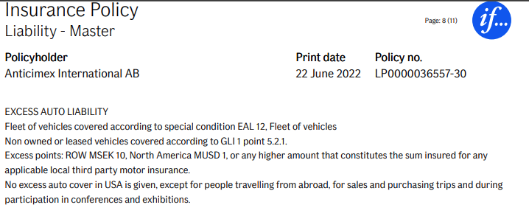

False or incorrect answer would be list of policies missing some actual cases or containing false positives, or wrong figures.

Question 2:
Identify policies covering offshore risks/projects.
This can be answered by reading various text fields in LH and the policy document trying to find hints about offshore nature of insured risk or provided cover, such as word “offshore” mentioned somewhere, or mentions that risk is located at sea or something like that written in various languages. See policy document for example for policy LP0000050118.
False or incorrect answer would be list of policies missing some actual cases or containing false positives

Question 3:
Identify policies insuring a layer of the risk. Find excess point and limit. Group together policies insuring different layers of the same risk.
Answer involves going through policies and finding relevant information from documents or text fields to identify if the policy is part of a layered solution and in such a case list layer parameters. It is also required to go through other policies belonging to the same parent original policyholder to identify policies that possibly insure other layers of the same risk and grouping that information together.
Flaws in this question are for example not recognizing such cases from portfolio, including polices not belonging to layered solutions, and in included policies showing incorrect layer parameters

